Subject: CODIS DNA Collection Sample Policy Template

Authority: O.R.C. 109.573, 2901.07, 2152.74 (Senate Bill 77)

Effective Date: July 1, 2011 (updated January 17, 2019)

Agencies Affected: Ohio Arresting Authorities

Questions: Diane Gehres, MS [740.845.2522], Ohio CODIS Administrator

Order: CODIS DNA Collection Kits and to obtain a fillable collection form contact codis@ohioattorneygeneral.gov

Disclaimer: This sample policy is to serve as a guide; agencies should refer to their legal counsel for final review of their internal policy and the statements within the policy.

Objective
The objective of this policy is to establish consistent procedures and guidelines for collecting and submitting DNA specimen samples from individuals described in Ohio Revised Code (O.R.C.) 2901.07 and O.R.C. 2152.74.

Agencies Affected
The policy and procedures apply to all persons employed or contracted by the (Insert Agency Name) that are authorized and required to collect DNA specimen samples under O.R.C. 2901.07 and O.R.C. 2152.74 and all individuals arrested, booked, confined, convicted or under supervision by (Insert Agency Name) that are required to submit to DNA specimen sample collection under O.R.C. 2901.07 and O.R.C. 2152.74.

Policy
It is the policy of (Insert Agency Name) that all individuals identified as meeting a qualifying offense pursuant to O.R.C. 2901.07 and O.R.C. 2152.74 shall submit to a DNA sample collection procedure administrated by (Insert Agency Name or the Agency Name Collecting the sample).

Individuals whose identity has been verified through fingerprints (or government issued identification card) and whose Ohio’s computerized criminal history (CCH) is marked “DNA is registered in the Ohio DNA Databank (CODIS)”, do not need to collect a DNA sample from the arrestee/offender. See Ohio Administrative Code 109:5-5-01 and 109:5-5-02.

An individual’s CCH and DNA status shall be checked each time an individual is in custody to ensure the DNA status not changed from a positive statement to a negative.

If the individual’s CCH history is marked in the negative “Not Collected for the Ohio DNA Offender Databank (CODIS)” or the identity of the individual cannot be determined, a CODIS DNA sample shall be taken from the individual.

It is the policy of the (Insert Agency Name) that all individuals marked as not having a DNA sample and do not have a current qualifying offense pursuant to O.R.C. 2901.07 and O.R.C. 2152.74, but should have been collected for a previous offense shall (Inset policy here):

It is the policy of the (Insert Agency Name) that all individuals identified as meeting a qualifying offense pursuant to O.R.C. 2901.07 and O.R.C. 2152.74 and have submitted a DNA specimen collected by (Insert Collection Agency Name) will have information recorded by the agency as to the date of the CODIS DNA collection.

It is the policy of the (Insert Agency Name) to handle individuals that refusal to submit to a CODIS DNA collection (Insert Policy Here):

It is the policy of the (Insert Agency Name) to run the Negative DNA Flag Offender Report on a monthly basis to monitor CODIS DNA collections and determine the reason an individual is on the report. This information shall be documented.

It is the policy of the (Insert Agency Name) to review all recollection requests and have a new CODIS DNA sample and DNA Database Collection form obtained from the individual, if possible. This information shall be documented.

It is the policy of the (Insert Agency Name) to ensure all employees responsible for performing or overseeing CODIS DNA collections at a minimum view the online training video provided by the Bureau of Criminal Investigation (BCI) and review this agencies procedures for CODIS DNA collections.

Procedure

Materials: DNA collection kits from BCI, disposable protective gloves, fingerprint specific inkpad, non-smearing ink pen and a fillable DNA collection form.

DNA Kit Components: buccal collector, transport pouch, return envelope with prepaid postage or a secondary transport envelope.

Once an individual has been identified as qualifying for CODIS DNA collection, work with one individual at a time in order to collect a DNA sample. This will reduce any errors that may occur.

- Identification of Individual.
Verification of identity may be accomplished by (1) running the fingerprints through a Rapid ID device or (2) referencing government–issued photo identification.

If the individual has been previously arrested, he or she will have a BCI number assigned, which must be recorded on the DNA collection form. If no BCI number is available, use the Incident Tracking Number (ITN) associated with the fingerprints submitted to BCI for the arrest. Complete the additional information required including collection agency ORI number, demographic information and qualifying offense.
The DNA collection form is used to document the individual’s demographic information, qualifying offense, date of collection and collecting agency information. This form is fillable and all demographic information should be typed. If an error is determined after the form is printed, simply put a line through the incorrect information and write the correct information above or below the line. Initial the correction.

After the DNA database collection form is printed, have the individual whose DNA is being collected sign the form in the “Subject’s Signature” box.

- Fingerprints
It is very important to get a clear and legible fingerprints showing ridge detail on the form. The form has a space to print 4-right fingers as a flat impression. If the offender does not have a right hand, use the left hand and note “LEFT” on the form.

The individual’s hand should be clean and dry. Press the right hand’s 4-fingers simultaneously flat against the inkpad and transfer to designated space on the printed DNA collection form. Please ensure that the tips of the fingers are included within the box as it is not necessary for the entire finger to show, see Figure 1 for an example.

If the quality of the print is poor use the back of the form to take additional flat impressions.

Figure 1. Example of a good 4-finger flat impression

- Collection of DNA Sample
Put on gloves to prevent contamination. Use gloved hand to partially remove the DNA collector from the package, leaving the filter paper end in the package. Using a non-smearing ink pen, write the individual’s last name & BCI number, Incident Tracking Number, or Social Security Number on the white area of the handle. See Figure 2 for an example.

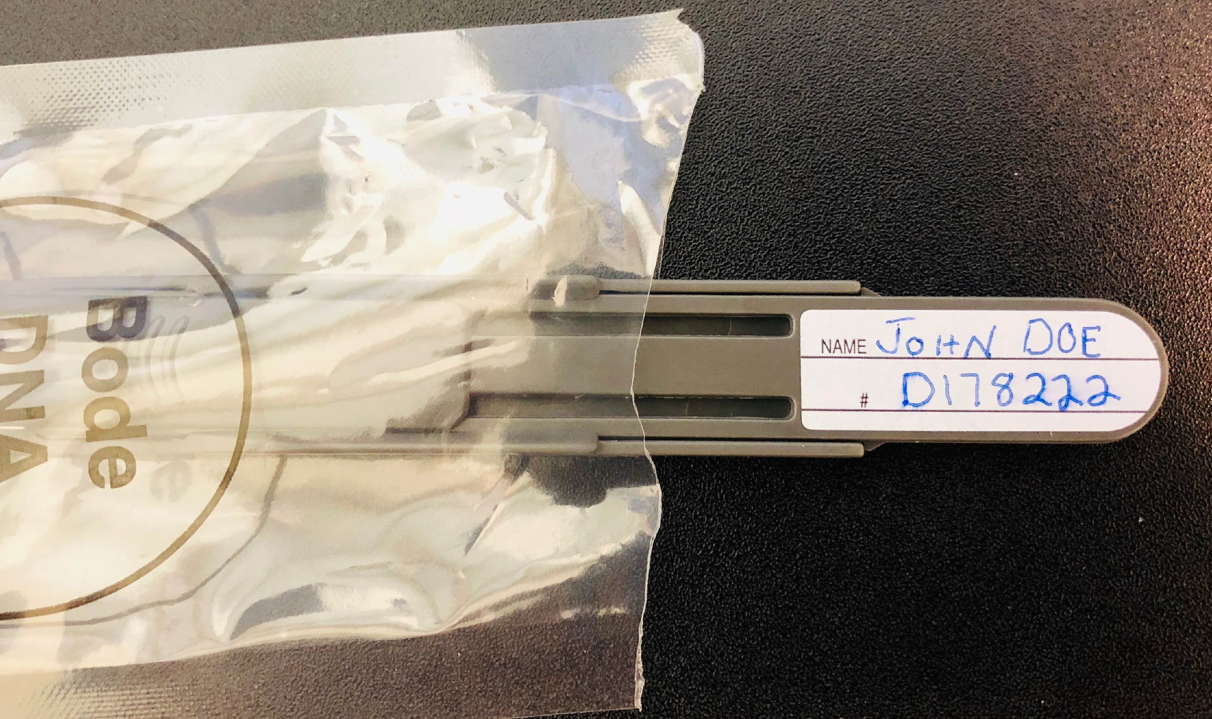
Figure 2. Example of a properly labeled DNA collector handle

Remove the DNA collector and discard the plastic wrapper. Hold the DNA collector with thumb on the area marked “Thumb”. If needed slide the gray cover down to expose the white filter paper. Instruct the individual to open their mouth. Place the filter paper side of the collector in the individual’s mouth flat against the inside cheek. With the collector pressed against the cheek drag it toward the individual’s lips. Repeat this action for a total of 7 times. A slight bulge in the individual’s cheek should be seen.

Do not rub the collector back-n-forth causing the paper to crumple. Do not have the individual spit on the collector; DNA is obtained from the cheek cells not the saliva.

Push the slide to cover the filter paper. Do not touch, sneeze, or cough on the filter paper.

- Packaging of the DNA Specimen
Place the DNA in the provided transport pouch and seal. Place the completed DNA collection form and the transport pouch into either a prepaid mailing envelope addressed to BCI or into a transport envelope for bulk shipment. The outer envelope shall contain one collection form and one transport pouch sealed per envelope instructions.

Take off gloves.

- Mailing the Completed DNA Collection Kit
Completed CODIS DNA collections shall be forwarded to BCI no later than 15 days after the date of the collection, O.R.C. 2901.07 and 2152.74.

(Insert agencies instructions on how information regarding which individual is collected for CODIS and the date of collection is documented.)

(Insert agencies procedures as to where the completed DNA collections are stored before each sample is individually mailed or shipped in bulk. It is recommended that agencies that send samples in bulk make a manifest to ensure all samples are in the box before it is shipped to BCI.))

